** WNMC Library – New Items Fall 2021**

[Art of Dying Well: A Practical Guide to a Good End of Life](https://wnmc.libib.com/#90272322X), The

Katy Butler

**2020**    288 Pages    (Scribner)

**Call #:** 616.02 But

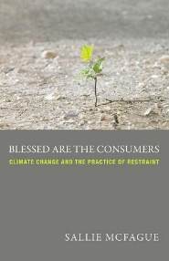

[Blessed Are the Consumers: Climate Change and the Practice of Restraint](https://wnmc.libib.com/#90274518X)

Sallie Mcfague

**2013**    225 Pages    (Augsburg Fortress, Publishers)

**Call #:** 261.88 McF

[Church of the Wild: How Nature Invites Us into the Sacred](https://wnmc.libib.com/#90278575X)

Victoria Loorz

**2021**    245 Pages    (Broadleaf Books )

**Call #:** 261.88 Loo

[ColorFull: Celebrating the Colors God Gave Us](https://wnmc.libib.com/#90275932X)

Dorena Williamson, Cornelius Van Wright (Illustrator), Ying-Hwa Hu (Illustrator)

**2018**    32 Pages    (B&H Publishing Group)

**Call #:** J Wil

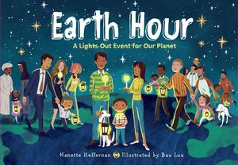[Earth Hour: A Lights-Out Event for Our Planet](https://wnmc.libib.com/#90276236X)

Nanette Heffernan, Bao Luu (Illustrator)

**2020**    32 Pages    (Charlesbridge Publishing, Incorporated)

**Call #:** J Hef

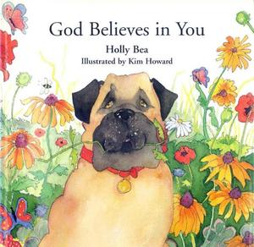[God Believes in You](https://wnmc.libib.com/#90278123X)

Holly Bea

**2011**    32 Pages    (H J Kramer)

**Call #:** J Bea

[God Made Me and You: Celebrating God's Design for Ethnic Diversity](https://wnmc.libib.com/#90276024X)

Shai Linne, Trish Mahoney (Drawings by)

**2018**    30 Pages    (New Growth Press)

**Call #:** J Linne

[God Unbound: Theology in the Wild](https://wnmc.libib.com/#90272570X)

Brian D. McLaren

**2019**    282 Pages    (Canterbury Press)

**Call #:** 918.66 McL



[Horse Lake Chronicles](https://wnmc.libib.com/#90274419X)

Aldred Neufeldt

**2020**    192 Pages    (Your Nickel's Worth Publishing)

**Call #:** 971.2 Neu

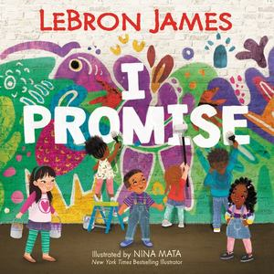[I Promise](https://wnmc.libib.com/#86016751X)

LeBron James, Nina Mata (Illustrator)

**2020**    40 Pages    (HarperCollins Canada, Limited)

**Call #:** J Jam

[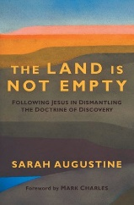Land Is Not Empty: Following Jesus in Dismantling the Doctrine of Discovery](https://wnmc.libib.com/#90271428X), The

Sarah Augustine

**2021**    248 Pages    (Herald Press)

**Call #:** 261.7 AUGU

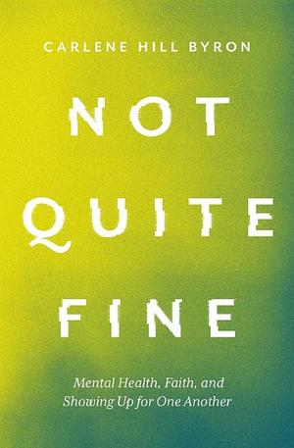[Not Quite Fine: Mental Health, Faith, and Showing Up for One Another](https://wnmc.libib.com/#90278458X)

Carlene Hill Byron

**2021**    223 Pages    (Herald Press)

**Call #:** 259.42 Byr

[Peace by Chocolate: The Hadhad Family's Remarkable Journey from Syria to Canada](https://wnmc.libib.com/#90274187X)

Jon Tattrie

**2020**    216 Pages    (Goose Lane Editions)

**Call #:** 971.6 Tat

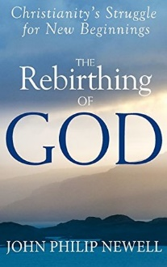[Rebirthing of God: Christianity's Struggle for New Beginnings, The](https://wnmc.libib.com/#90275801X)

John Philip Newell

**2015**    160 Pages    (SkyLight Paths)

**Call #:** 230 New

[Rise And Shine: 45 Years In The Land Of The Rising Sun](https://wnmc.libib.com/#87078926X)

Mary Derksen

**2018**    338 Pages    (Lulu.com)

**Call #:** 266 Der

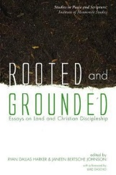[Rooted and Grounded: Essays on Land and Christian Discipleship](https://wnmc.libib.com/#90271977X)

Ryan Dallas Harker (Editor), Janeen Bertsche Johnson (Editor), Luke Gascho (Foreword)

**2016**    282 Pages    (Pickwick Publications)

**Call #:** 261.88 Har

[Schoenbrunn Chronicles, The](https://wnmc.libib.com/#90277954X)

Lieselotte Dück, Agnes Balzer (Compiled by), Esther Regehr, Henry Regehr

**2009**    (Sweetwater Press)

**Call #:** 289.78 Bal

[Space Between Us: Conversations about Transforming Conflict](https://wnmc.libib.com/#90275609X), The

Betty Pries

**2021**    231 Pages    (Herald Press)

**Call #:** 248.4 Pri

[We Are Water Protectors](https://wnmc.libib.com/#90276347X)

Carole Lindstrom, Michaela Goade (Illustrator)

**2020**    40 Pages    (Roaring Brook Press)

**Call #:** J Lind

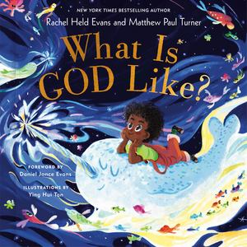[What Is God Like?](https://wnmc.libib.com/#90276130X)

Rachel Held Evans, Matthew Paul Turner, Ying Hui Tan (Illustrator), Daniel Jonce Evans (Foreword by)

**2021**    40 Pages    (Convergent Books)

**Call #:** J Eva

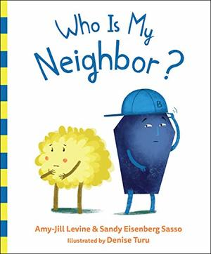[Who Is My Neighbor?](https://wnmc.libib.com/#90276474X)

Amy-Jill Levine, Sandy Eisenberg Sasso, Denise Turu (Illustrated by)

**2019**    32 Pages    (Flyaway Books)

**Call #:** J Lev

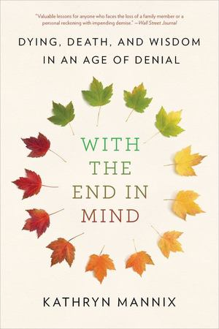[With the End in Mind: Dying, Death, and Wisdom in an Age of Denial](https://wnmc.libib.com/#90274754X)

Kathryn Mannix

**2018**    352 Pages    (Little, Brown Spark)

**Call #:** 616.02 Man