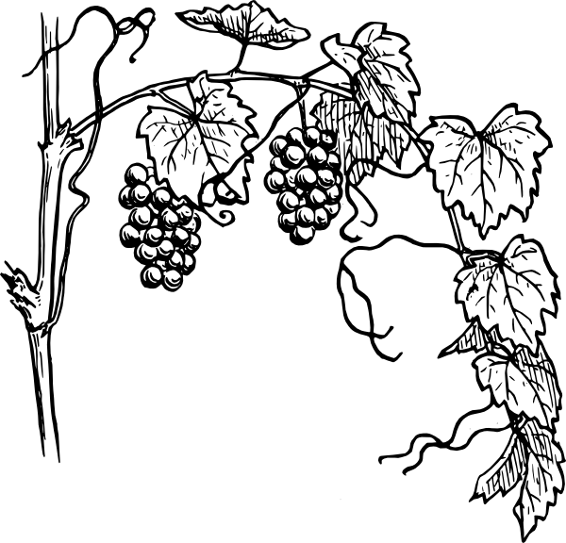

*I am the vine*

*you are the branches*

*John 15.5*

**Waterloo North Mennonite Church**

**Sunday February 10, 2019, 10:45 a.m.**

**Anabaptism: Discipleship**

Abiding in the vine and bearing fruit: during the season of Epiphany, we will explore the spiritual legacy of the Anabaptists, forebears of the Mennonites, by exploring the themes of regeneration, scripture, discipleship, nonresistance, and community.

**Gathering hymns:**

**Insert I will sing with you**

**HWB (blue) #544 When we walk with the Lord**

Welcome, introductions and announcements

**Call to worship and invocation**

(From *Spacious Faith*, based on Psalm 22, Matthew 16:21-28)

Leader: We come to worship this morning from different places.

**People: O God, do not be far from us.**  
Leader: We come to worship this morning for different reasons.

**People: O God, do not be far from us.**

Leader: We experience the presence of the Spirit in different ways.

**People: O God, do not be far from us.**

Leader: We hear Jesus’ words with different ears.  
**People:** **O God, do not be far from us.**

Leader: “Deny yourselves.”

**People:** **O God, do not be far from us.**

Leader: “Take up your cross.”

**People:** **O God, do not be far from us.**

Leader: “Follow me.”

***All:******O God, we thank you for drawing near to us in this place, in***

***our lives. We will respond. Amen.***

**Hymn: STJ (green) #17 Halle, halle, hallelujah!**

Children’s time: Anabaptists in Caribbean, Central and South America

Offering

**Offertory Hymn: STJ (green) #77 The peace of the earth be with you**

Congregational Prayer

**Hymn: HWB (blue) #535 Who would now follow Christ**

Scripture reading: Matthew 16:24-27; Galatians 5:22-25 *(see last page)*

**Hymn: HWB (blue) #438 I sing with exultation**

Sermon: *“To Follow is to Know”*

**Hymn of Response: HWB (blue) #546 Guide my feet**

Benediction

*******************

*With gratitude and respect, we recognize that we are worshipping on the*

*traditional land that once belonged to the Haudenosaunee and Anishnaabe peoples. We regret the lack of respect given to the Indigenous people in the past,*

*and pledge to work for justice and reconciliation.*

*******************

**Headsets** for hearing assistance are available from the ushers.

**Childcare** (infants to age 4): The nursery is located next to the sanctuary. Infant change table is located in washroom next to nursery.  Ushers can direct you.

**Children’s Worship Binder**, an instrument to help children through the worship service, is available by the sanctuary entrance.

**Offering** Thank you to those who contribute electronically.  Offering cards are available (or use loose change/cash) so that you can participate in the giving of offering worship experience.

**Welcome Visitors** We are glad you are worshipping with us this morning. If you would like to learn more about our church and our ministries, including our care groups, education opportunities, seniors group or youth groups, and if you’d like to be added to our email list, please contact the church office or one of the ministers.

***At Waterloo North Mennonite Church we welcome***

***all people to participate fully in our Christian community***

***of faith with all its expectations, responsibilities, and opportunities regardless of personal characteristics***

***such as race, ethnic background, age, gender and***

***gender identity, sexual orientation, income, or education***

Matthew 16:24-27  (NRSV)

24Then Jesus told his disciples, “If any want to become my followers, let them deny themselves and take up their cross and follow me. 25For those who want to save their life will lose it, and those who lose their life for my sake will find it. 26For what will it profit them if they gain the whole world but forfeit their life? Or what will they give in return for their life?

27“For the Son of Man is to come with his angels in the glory of his Father, and then he will repay everyone for what has been done.

Galatians 5:22-25 (NRSV)

**22**By contrast, the fruit of the Spirit is love, joy, peace, patience, kindness, generosity, faithfulness, **23**gentleness, and self-control. There is no law against such things. **24**And those who belong to Christ Jesus have crucified the flesh with its passions and desires. **25**If we live by the Spirit, let us also be guided by the Spirit.

.